**JavaScript Exercises**

1. Write a program in Javascript to create variables to store numeric, float, string and Boolean values and show them in page with document.write() function.

ANSWER:

<!DOCTYPE html>

<html>

<head>

<meta charset="utf-8">

<title>JS1</title>

<script type="text/javascript">

var a = 10 +"<br>";

var b = parseFloat("10.1")+"<br>";

var str ="shreya singh" +"<br>";

var test1 = new Boolean(0);

document.write("String is :",str);

document.write("A =", a);

document.write("B =",b);

document.write("Value is ",test1);

</script>

</head>

<body>

</body>

</html>

1. Write a program to input two data values for Your Name and Student Id in prompt dialog boxes and show them in alert dialog box.

ANSWER:

<!DOCTYPE html>

<html>

<head>

<meta charset="utf-8">

<title>JS3</title>

<script type="text/javascript">

var marks= 80;

if (marks >= 80 && marks <= 100)

{

document.write("Distinction");

}

else if(marks>=60 && marks<80 )

{

document.write("First Division");

}

else if(marks>=50 && marks<60)

{

document.write("Second Division");

}

else if(marks>= 40 && marks <50)

{

document.write("Third Division");

}

else

{

document.write("Fail");

}

</script>

</head>

<body>

</body>

</html>

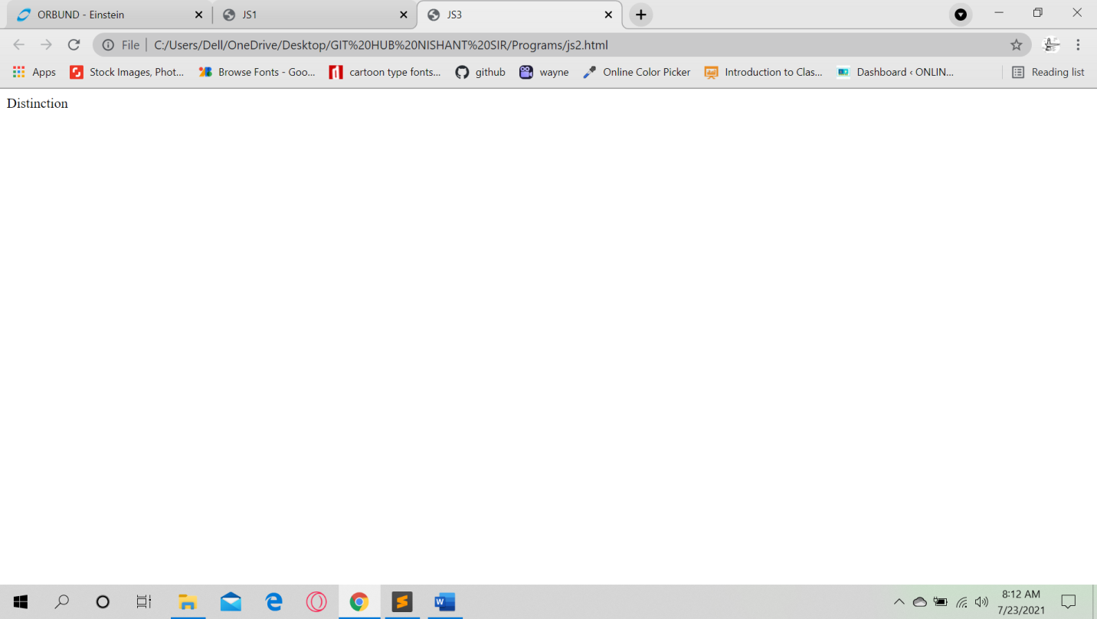

1. WAP to show the use if…. Else if …. else for following conditions:
   1. For marks > = 80 and marks <=100, show Distinction
   2. For marks >=60 and marks < 80, show First Division
   3. For marks >=50 and marks < 60, show Second Division
   4. For marks >=40 and marks <50, show Third Division
   5. For marks < 40, show Fail

<!DOCTYPE html>

<html>

<head>

<meta charset="utf-8">

<title>JS2</title>

<script type="text/javascript">

x = prompt("Enter your name","")

y = prompt("Enter your Student ID:","")

document.write("Name: <br>"+x)

document.write("<br>Student ID: <br>" +y)

</script>

</head>

<body>

</body>

</html>

1. WAP to get number input with prompt dialog dox and show the Day using switch case
   1. For Case 1, show Sunday
   2. For Case 2, show Monday
   3. For Case 3, show Tuesday
   4. For Case 4, show Wednesday
   5. For Case 5, show Thursday
   6. For Case 6, show Friday
   7. For Case 7, show Saturday
   8. For default, show Invalid

ANSWER:

<!DOCTYPE html>

<html>

<head>

<meta charset="utf-8">

<title></title>

<script type="text/javascript">

document.write("The day is:")

var day= 6;

switch (day){

case 1:

document.write("Sunday");

break;

case 2:

document.write("Monday");

break;

case 3:

document.write("Tuesday");

break;

case 4:

document.write("Wednesday");

break;

case 5:

document.write("Thursday");

break;

case 6:

document.write("Friday");

break;

case 7:

document.write("Saturday");

break;

default:

document.write(" wrong input");

break;

}

</script>

</head>

<body>

</body>

</html>

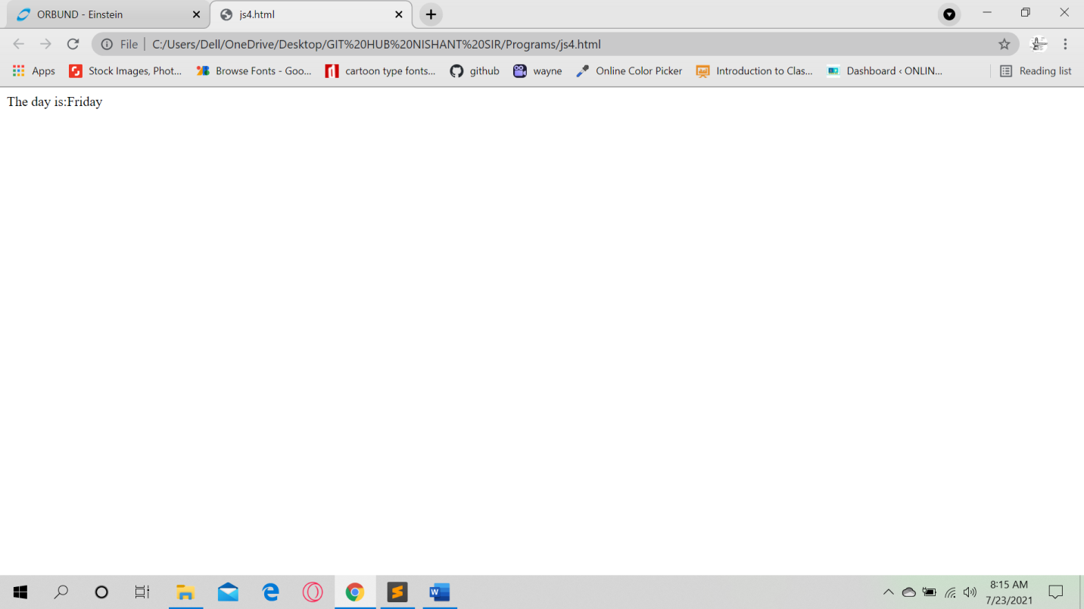

1. WAP in javascript using for loop to display 4 images with image name as 1.jpg, 2.jpg, 3.jpg and 4.jpg.
2. WAP to display multiplication number of 5 as follows:

5 * 1 = 5

5 * 2 = 10

5 * 3 = 15

……………

…………….

5 * 10 = 50

ANSWER:

<!DOCTYPE html>

<html>

<head>

<meta charset="utf-8">

<title>JS 6</title>

</head>

<body>

<script type="text/javascript">

var num =parseInt(prompt("Enter any number: "));

for (var i = 1; i <= 10; i++)

{

document.write(num+ " * " + i + " = " + num*i + "<br>");

}

</script>

</body>

</html>

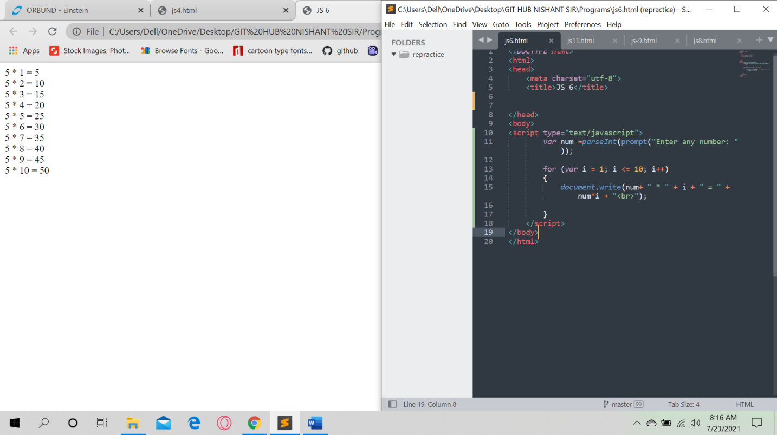

1. WAP in javascript using loop to display following table layout and with alternate background color on data rows

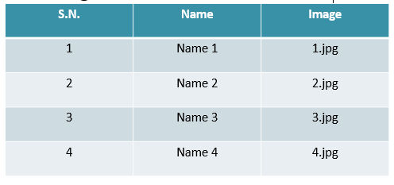

1. Write a simple JavaScript program to join all elements of the following array into a string. *Sample array* : myColor = ["Red", "Green", "White", "Black"];

*Expected Output* :   
"Red,Green,White,Black"  
"Red,Green,White,Black"  
"Red+Green+White+Black"

**Hint: Use these array functions**

myColor.toString();

myColor.join();

myColor.join('+');

ANSWER:

<!DOCTYPE html>

<html>

<head>

<meta charset="utf-8">

<title>Java Script =8</title>

<script type="text/javascript">

var myColor =["RED", "GREEN", "WHITE","BLACK"]

myColor.toString();

myColor.join();

myColor.join('+');

document.write("<br>"+ myColor.join(','));

document.write("<br>"+ myColor.join(','));

document.write("<br>"+ myColor.join('+'));

</script>

</head>

<body>

</body>

</html>

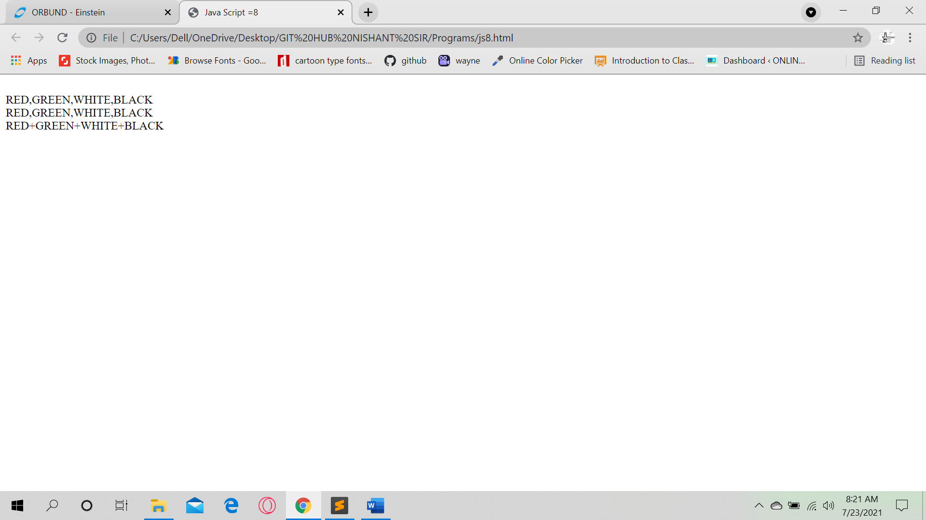

1. Write a JavaScript program to compute the sum and product of an array of integers.

ANSWER:

<!DOCTYPE html>

<html>

<head>

<meta charset="utf-8">

<title>Javascript 9</title>

</head>

<body>

<script type="text/javascript">

var array = [1, 2, 3, 4, 5, 6],

s = 0,

p = 1,

i;

for (i = 0; i < array.length; i += 1)

{

s += array[i];

p *= array[i];

}

document.write("Sum : "+s + " Product : " +p);

</script>

</body>

</html>

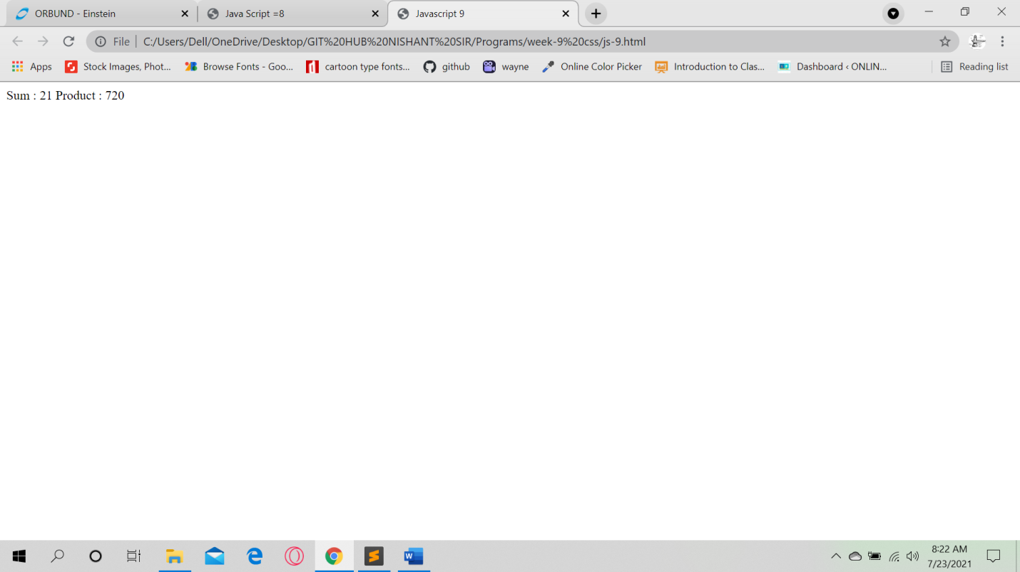

1. Write a Javascript function to calculate area of rectangle which accepts two parameters – length and breadth.

ANSWER:

<!DOCTYPE html>

<html>

<head>

<meta charset="utf-8">

<title>Javascript 10</title>

<script type="text/javascript">

var length = 10;

var breadth = 8;

area = length * breadth;

document.write("The area of the rectangle is: " +area);

</script>

</head>

<body>

</body>

</html>

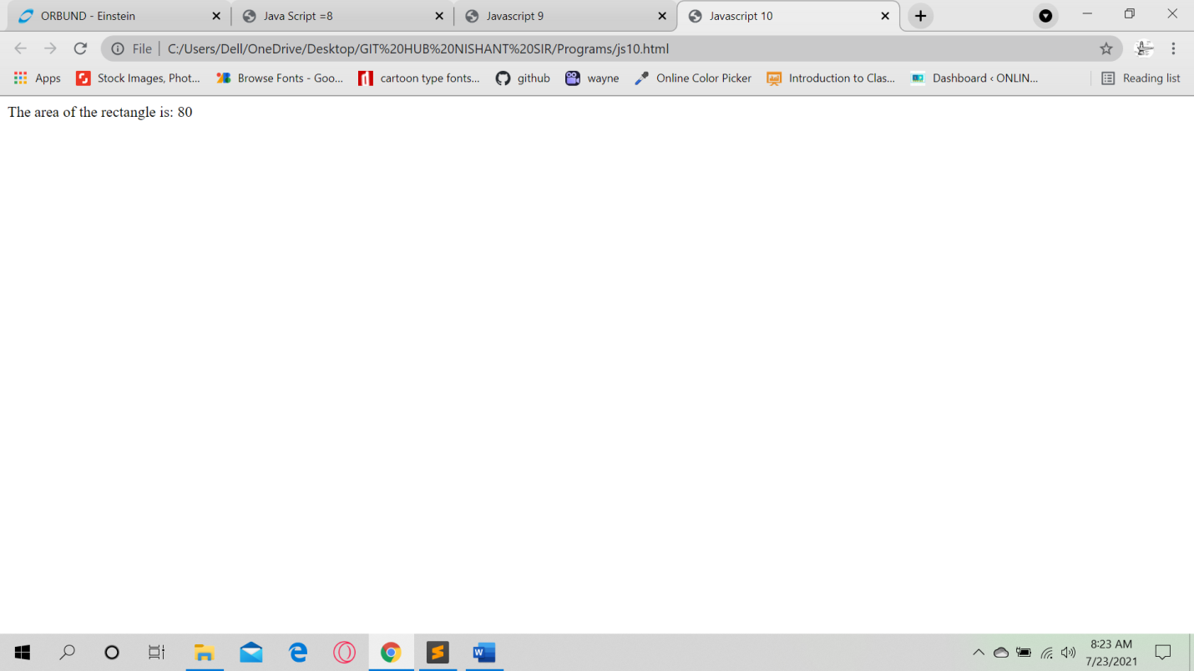

1. Write a JavaScript program to add items in an blank array and display the items using function.

Sample screen:

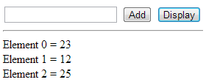

**Hint:**

function add_item_to_array()

{

array[x] = document.getElementById("text1").value;

alert("Element: " + array[x] + " Added at index " + x);

x++;

document.getElementById("text1").value = "";

}

function display_array()

{

var e = "<hr/>";

for (var y=0; y<array.length; y++)

{

e += "Element " + y + " = " + array[y] + "<br/>";

}

document.getElementById("Result").innerHTML = e;

}

<input type="text" id="text1"></input>

<input type="button" id="button1" value="Add" onclick="add_element_to_array();"></input>

<input type="button" id="button2" value="Display" onclick="display_array();"></input>

<div id="Result"></div>

ANSWER:

<!DOCTYPE html>

<html>

<head>

<meta charset="utf-8">

<title>Javascript 11 </title>

<script type="text/javascript">

var x=0;

var array=Array();

function add_item_to_array()

{

array[x]=document.getElementById("text1").value;

alert("Element: "+ array[x] + "Added at index" +x);

x++;

document.getElementById("text1").value="";

}

function display_array(){

var e ="<hr/>";

for (var y=0; y<array.length; y++) {

e += "Element" + y + "=" +array[y]+"<br/>";

}

document.getElementById("Result").innerHTML = e;

}

</script>

</head>

<body>

<input type="text" id="text1"></input>

<input type="button" id="button1" value="Add" onclick="add_item_to_array();"></input>

<input type="button" id="button2" value="Display" onclick="display_array();"></input>

<div id="Result"></div>

</body>

</html>

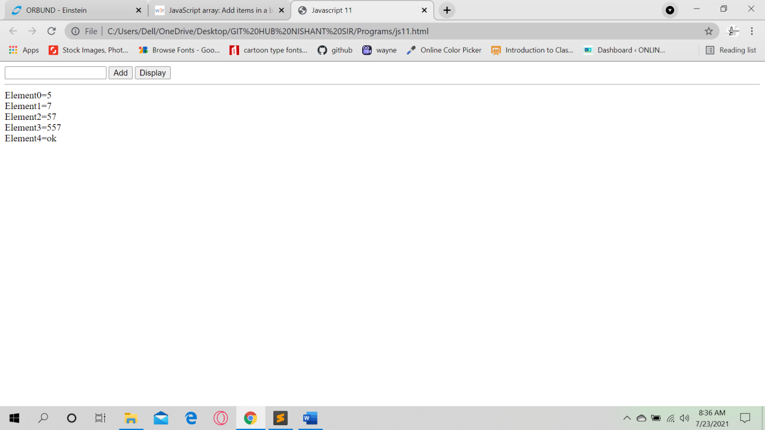

Solution

1.

myColor = ["Red", "Green", "White", "Black"];

alert(myColor.toString());

alert(myColor.join());

alert(myColor.join('+'));

2.

var x = 0;

var array = Array();

function add_element_to_array()

{

array[x] = document.getElementById("text1").value;

alert("Element: " + array[x] + " Added at index " + x);

x++;

document.getElementById("text1").value = "";

}

function display_array()

{

var e = "<hr/>";

for (var y=0; y<array.length; y++)

{

e += "Element " + y + " = " + array[y] + "<br/>";

}

document.getElementById("Result").innerHTML = e;

}

<input type="text" id="text1"></input>

<input type="button" id="button1" value="Add" onclick="add_element_to_array();"></input>

<input type="button" id="button2" value="Display" onclick="display_array();"></input>

<div id="Result"></div>

3.

var array = [1, 2, 3, 4, 5, 6],

s = 0,

p = 1,

i;

for (i = 0; i < array.length; i += 1)

{

s += array[i];

p *= array[i];

}

alert('Sum : '+s + ' Product : ' +p);